Homework 10

1.Please use recursive function to compute the following:

(a). S = 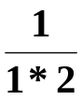 + 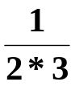 + 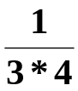 + … + 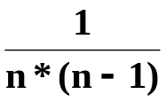
(Think about when n becomes to 2 what the value of this term)

(b). π= 4 * 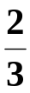 *  *  * 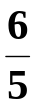 * 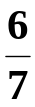 *  * …
(You may consider ( and ), ( and ), ( and ), …as one pair and let n=0 as 4 )

(c). (加分題,可不寫)From (b) and using the constant M_PI in the math.h to find the approximated value of π till the error between M_PI and your approximated valueπreduces to 0.005.

- Write a program that inputs two numbers: x and y. (data are all integers) in the main program and passes these two numbers
( pass by value) to the recursive function: power that returns
the 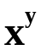.

If y ≧0,
1 if y=0
power(x, y)= x if y=1
x*power(x,y-1) if y>1
If y<0

power(x, y)= 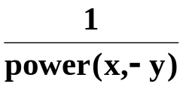

Print the result in the main program.

3. A robot can take steps of 1meter, 2 meters and 3 meters.
Write a recursive function to evaluate the number of ways the
robot can walk n meters.

4.(加分題, 可以不寫) This is an extra point question, you may not write.
A robot can take steps of 1meter, 2 meters. Write a
function that lists all of the ways that the robot can walk n meters.

5. (加分題, 可以不寫) This is an extra point question, you may not write.
Suppose that we have a 2 × n rectangular board divided into 2n squares. Write a function that computes the number of ways to cover this board exactly by 1 × 2 dominoes.

